Andrew Kling   
UNCC Data Visualization HW#2

Screenshots from Excel Worksheets

**2016**

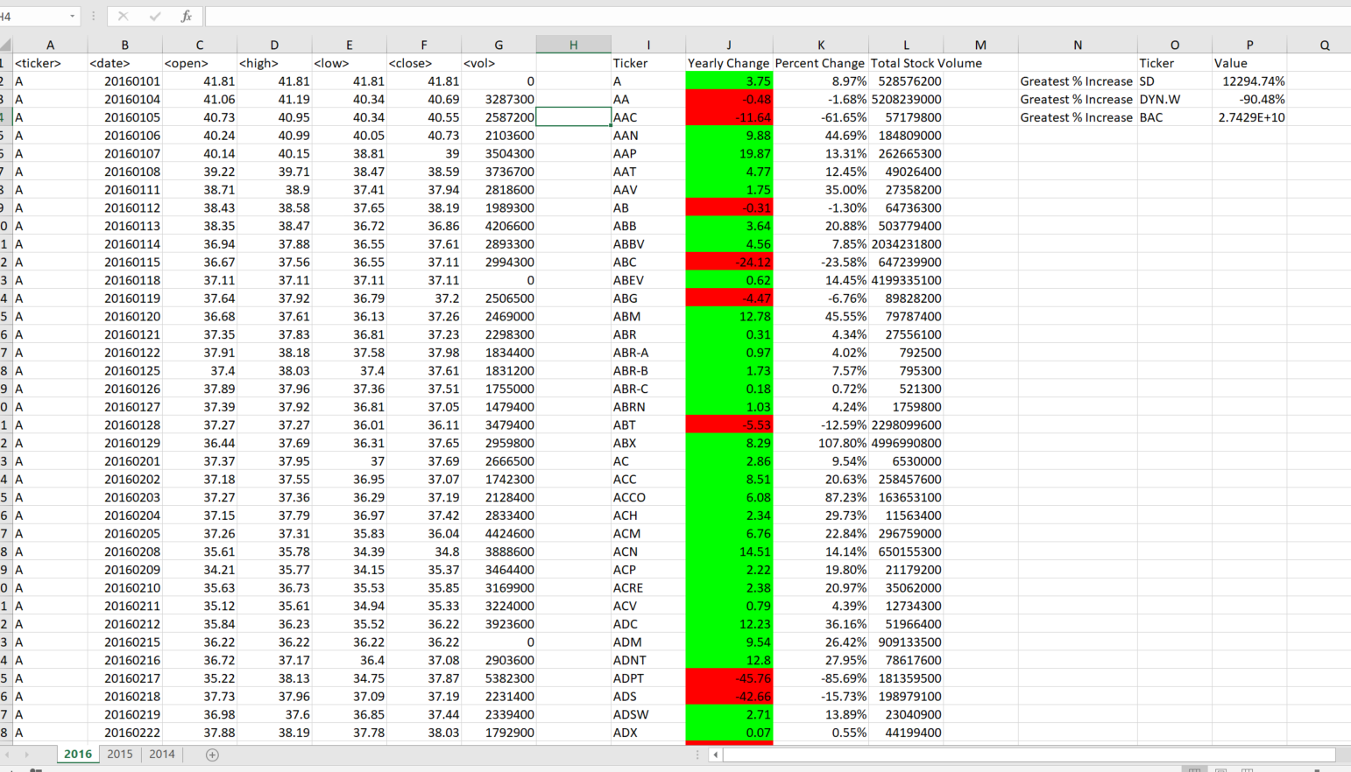

**2015**

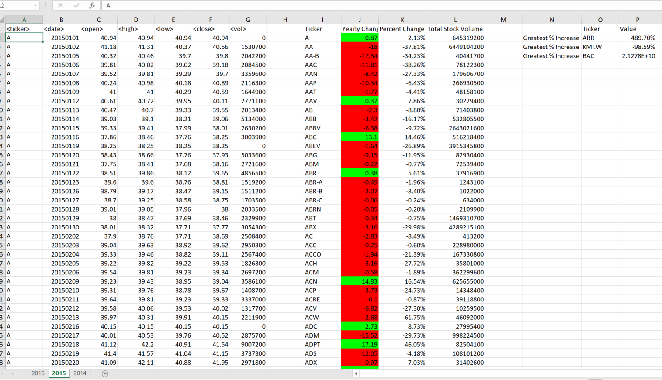

**2014**

